# **Weekly Report – W8 Fall 2022**

## **Problem**

1. Derive the governing equation of a two-link pendulum model using forward kinematics.
2. Clarify where the ode solver in Simulink is applied.
3. Accomplish the design of exoskeleton supplement part used on thigh.

## **Solution**

1. *Governing Equation Derivation*

Since last week I have faced difficulties with deriving the inertia matrix in the governing equation, and meanwhile I haven’t figured out any effective methods to verify the correctness of the matrix, a potential solution was proposed that using the same rule for deriving the inertia matrix of two-link SRA for simulation, if the results of a much simpler model (two-link pendulum) were proved to be right, that is to say there should not be any issues with the matrix calculation for SRA.

#### (1). Coordinate system establishment & Rotation matrix calculation

The coordinate system has been set up according to the D-H convention as shown in the figure below, and for the convenience of checking afterwards, each transformation will be elaborately described.

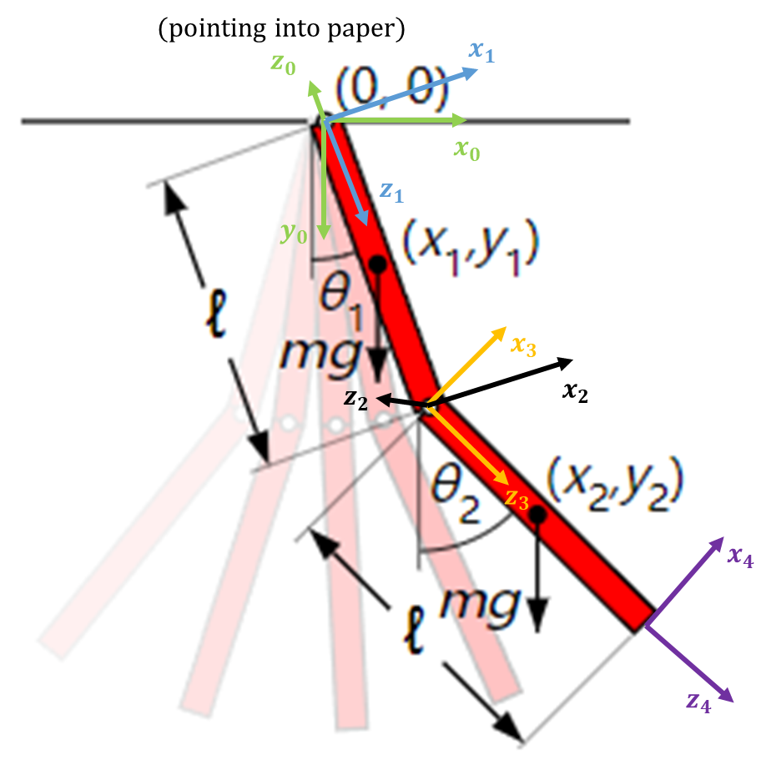

**Fig. W8-1** The schematic of the two-link pendulum system and the coordinate system setting up

1). Frame 0 $→$ Frame 1: (for the subsequent steps, F will stand for the Frame), we need to rotate the coordinate around $z_{0}$ axle by $-θ_{1}$ and then rotate around $x_{0}$ axle by $-\frac{π}{2}$ to obtain F1;

2). F1 $→$ F2: do prismatic operation along $z_{1}$ axle by $l_{1}$ and then rotate the coordinate around $x_{1} \left(also x_{2}\right)$ by $\frac{π}{2}$ to obtain F2;

3). F2 $→$ F3: we can first rotate the system around $z_{2}$ by $-\left(θ_{2}-θ_{1}\right)$ and then rotate the system around $x_{3}$ by $-\frac{π}{2}$;

4). F3 $→$ F4: we just need to do prismatic operation on the system along the $z_{3}$ by $l_{2}$ to obtain the final frame.

All these steps can be summarized in the D-H parameter table as follows,

|  |  |  |  |  |
| --- | --- | --- | --- | --- |
| **Link No.** | $$θ_{i}$$ | $$d_{i}$$ | $$α_{i}$$ | $$a_{i}$$ |
| 1 | $$-θ_{1}$$ | 0 | $$-\frac{π}{2}$$ | 0 |
| 2 | 0 | $$l_{1}$$ | $$\frac{π}{2}$$ | 0 |
| 3 | $$-\left(θ_{2}-θ_{1}\right)$$ | 0 | $$-\frac{π}{2}$$ | 0 |
| 4 | 0 | $$l_{2}$$ | 0 | 0 |

$$\begin{aligned}∴ R_{1}^{0}=\left[\begin{matrix}\cos\left(-θ_{1}\right) & -\sin\left(-θ_{1}\right) & 0 & 0 \\ \sin\left(-θ_{1}\right) & \cos\left(-θ_{1}\right) & 0 & 0 \\ 0 & 0 & 1 & 0 \\ 0 & 0 & 0 & 1\end{matrix}\right]\left[\begin{matrix}1 & 0 & 0 & 0 \\ 0 & \cos\left(-\frac{π}{2}\right) & -\sin\left(-\frac{π}{2}\right) & 0 \\ 0 & \sin\left(-\frac{π}{2}\right) & \cos\left(-\frac{π}{2}\right) & 0 \\ 0 & 0 & 0 & 1\end{matrix}\right]\end{aligned}$$

$$\begin{aligned}=\left[\begin{matrix}\cos{θ_{1}} & 0 & \sin{θ_{1}} & 0 \\ -\sin{θ_{1}} & 0 & \cos{θ_{1}} & 0 \\ 0 & -1 & 0 & 0 \\ 0 & 0 & 0 & 1\end{matrix}\right]\#\left(W8-1\right)\end{aligned}$$

$$\begin{aligned}R_{2}^{1}=\left[\begin{matrix}1 & 0 & 0 & 0 \\ 0 & 1 & 0 & 0 \\ 0 & 0 & 1 & l_{1} \\ 0 & 0 & 0 & 1\end{matrix}\right]\left[\begin{matrix}1 & 0 & 0 & 0 \\ 0 & \cos\left(\frac{π}{2}\right) & -\sin\left(\frac{π}{2}\right) & 0 \\ 0 & \sin\left(\frac{π}{2}\right) & \cos\left(\frac{π}{2}\right) & 0 \\ 0 & 0 & 0 & 1\end{matrix}\right]=\left[\begin{matrix}1 & 0 & 0 & 0 \\ 0 & 0 & -1 & 0 \\ 0 & 1 & 0 & l_{1} \\ 0 & 0 & 0 & 1\end{matrix}\right]\#\left(W8-2\right)\end{aligned}$$

$$R_{3}^{2}=\left[\begin{matrix}\cos\left[-\left(θ_{2}-θ_{1}\right)\right] & -\sin\left[-\left(θ_{2}-θ_{1}\right)\right] & 0 & 0 \\ \sin\left[-\left(θ_{2}-θ_{1}\right)\right] & \cos\left[-\left(θ_{2}-θ_{1}\right)\right] & 0 & 0 \\ 0 & 0 & 1 & 0 \\ 0 & 0 & 0 & 1\end{matrix}\right]\left[\begin{matrix}1 & 0 & 0 & 0 \\ 0 & \cos\left(-\frac{π}{2}\right) & -\sin\left(-\frac{π}{2}\right) & 0 \\ 0 & \sin\left(-\frac{π}{2}\right) & \cos\left(-\frac{π}{2}\right) & 0 \\ 0 & 0 & 0 & 1\end{matrix}\right]$$

$$\begin{aligned}=\left[\begin{matrix}\cos\left(θ_{1}-θ_{2}\right) & 0 & \sin\left(θ_{2}-θ_{1}\right) & 0 \\ \sin\left(θ_{1}-θ_{2}\right) & 0 & \cos\left(θ_{1}-θ_{2}\right) & 0 \\ 0 & -1 & 0 & 0 \\ 0 & 0 & 0 & 1\end{matrix}\right]\#\left(W8-3\right)\end{aligned}$$

$$\begin{aligned}R_{4}^{3}=\left[\begin{matrix}1 & 0 & 0 & 0 \\ 0 & 1 & 0 & 0 \\ 0 & 0 & 1 & l_{2} \\ 0 & 0 & 0 & 1\end{matrix}\right]\#\left(W8-4\right)\end{aligned}$$

As we only concern the states of the physical joints rather than the ones have been defined above, so for the subscripts of the following matrices, the letter $j$ stands for joint.

$$\begin{aligned}∴ R_{j1}^{0}=R_{1}^{0}R_{2}^{1}=\left[\begin{matrix}\cos{θ_{1}} & \sin{θ_{1}} & 0 & l_{1}\sin{θ_{1}} \\ -\sin{θ_{1}} & \cos{θ_{1}} & 0 & l_{1}\cos{θ_{1}} \\ 0 & 0 & 1 & 0 \\ 0 & 0 & 0 & 1\end{matrix}\right]\#\left(W8-5\right)\end{aligned}$$

$$\begin{aligned}R_{j2}^{0}=R_{j1}^{0}R_{3}^{2}R_{4}^{3}=\left[\begin{matrix}\cos{θ_{2}} & 0 & \sin{θ_{2}} & l_{1}\sin{θ_{1}}+l_{2}\sin{θ_{2}} \\ -\sin{θ_{2}} & 0 & \cos{θ_{2}} & l_{1}\cos{θ_{1}}+l_{2}\cos{θ_{2}} \\ 0 & -1 & 0 & 0 \\ 0 & 0 & 0 & 1\end{matrix}\right]\#\left(W8-6\right)\end{aligned}$$

#### (2). Key matrices & vectors identification in governing equation

The first three elements in the last column of both matrices above represent the coordinates (position) of the joints in the 2D plane with respect to the base frame, we can extract them out by two column vectors as follows,

$$\begin{aligned}p_{j1}^{0}=\left[\begin{aligned}l_{1}\sin{θ_{1}} \\ l_{1}\cos{θ_{1}} \\ 0\end{aligned}\right] p_{j2}^{0}=\left[\begin{aligned}l_{1}\sin{θ_{1}}+l_{2}\sin{θ_{2}} \\ l_{1}\cos{θ_{1}}+l_{2}\cos{θ_{2}} \\ 0\end{aligned}\right]\#\left(W8-7\right)\end{aligned}$$

In the case, the linear velocity can be worked out by differentiating all the elements about time, but before doing that, we have to convert the coordinate information from the joints to the COM (center of mass) of each link since the kinetic energy analysis is based on the COM no matter for linear or angular velocities. In the subsequent expressions, the subscript $c$ stands for the center of the link.

$$p_{c1}^{0}=\frac{1}{2}p_{j1}^{0}=\left[\begin{aligned}\frac{1}{2}l_{1}\sin{θ_{1}} \\ \frac{1}{2}l_{1}\cos{θ_{1}} \\ 0\end{aligned}\right] p_{c2}^{0}=p_{j1}^{0}+\frac{1}{2}\left(p_{j2}^{0}-p_{j1}^{0}\right)=\left[\begin{aligned}l_{1}\sin{θ_{1}} \\ l_{1}\cos{θ_{1}} \\ 0\end{aligned}\right]+\frac{1}{2}\left[\begin{aligned}l_{2}\sin{θ_{2}} \\ l_{2}\cos{θ_{2}} \\ 0\end{aligned}\right]$$

$$\begin{aligned}=\left[\begin{aligned}l_{1}\sin{θ_{1}}+\frac{1}{2}l_{2}\sin{θ_{2}} \\ l_{1}\cos{θ_{1}}+\frac{1}{2}l_{2}\cos{θ_{2}} \\ 0\end{aligned}\right]\#\left(W8-8\right)\end{aligned}$$

Then the linear velocities can be computed by the following steps,

$$v_{c1}={\dot{p}}_{c1}^{0}=\left[\begin{aligned}\frac{∂\left(\frac{1}{2}l_{1}\sin{θ_{1}}\right)}{∂θ_{1}}∙\frac{dθ_{1}}{dt}+\frac{∂\left(\frac{1}{2}l_{1}\sin{θ_{1}}\right)}{∂θ_{2}}∙\frac{dθ_{2}}{dt} \\ \frac{∂\left(\frac{1}{2}l_{1}\cos{θ_{1}}\right)}{∂θ_{1}}∙\frac{dθ_{1}}{dt}+\frac{∂\left(\frac{1}{2}l_{1}\cos{θ_{1}}\right)}{∂θ_{2}}∙\frac{dθ_{2}}{dt} \\ 0\end{aligned}\right]=\left[\begin{aligned}\frac{1}{2}l_{1}\cos{θ_{1}}∙{\dot{θ}}_{1} \\ -\frac{1}{2}l_{1}\sin{θ_{1}}∙{\dot{θ}}_{1} \\ 0\end{aligned}\right]$$

$$\begin{aligned}=\left[\begin{matrix}\frac{1}{2}l_{1}\cos{θ_{1}} & 0 \\ -\frac{1}{2}l_{1}\sin{θ_{1}} & 0 \\ 0 & 0\end{matrix}\right]\left[\begin{aligned}{\dot{θ}}_{1} \\ {\dot{θ}}_{2}\end{aligned}\right]\#\left(W8-9\right)\end{aligned}$$

Similarly, for the linear velocity of the COM of link 2, we have

$$\begin{aligned}v_{c2}={\dot{p}}_{c2}^{0}=\left[\begin{matrix}l_{1}\cos{θ_{1}} & \frac{1}{2}l_{2}\cos{θ_{2}} \\ -l_{1}\sin{θ_{1}} & -\frac{1}{2}l_{2}\sin{θ_{2}} \\ 0 & 0\end{matrix}\right]\left[\begin{aligned}{\dot{θ}}_{1} \\ {\dot{θ}}_{2}\end{aligned}\right]\#\left(W8-10\right)\end{aligned}$$

According to the canonical format depicting the relationship between linear velocities and state variable velocities, the linear part of the body Jacobian can be expressed by

$$\begin{aligned}J_{v1}=\left[\begin{matrix}\frac{1}{2}l_{1}\cos{θ_{1}} & 0 \\ -\frac{1}{2}l_{1}\sin{θ_{1}} & 0 \\ 0 & 0\end{matrix}\right] J_{v2}=\left[\begin{matrix}l_{1}\cos{θ_{1}} & \frac{1}{2}l_{2}\cos{θ_{2}} \\ -l_{1}\sin{θ_{1}} & -\frac{1}{2}l_{2}\sin{θ_{2}} \\ 0 & 0\end{matrix}\right]\#\left(W8-11\right)\end{aligned}$$

And for the angular velocities, there is no way to use the direct derivative method when it turns to be a 3D model, thereby, we need to find a more general way rather than using geometry factors. Once the rotation matrix has been confirmed, all the other terms can be computed automatically by definition, as we regulate that the rotational axle can only be z axle (the first three elements in the third column of joint rotation matrix), the twist vector can be extracted as

$$\begin{aligned}z_{j1}^{0}=\left[\begin{aligned}0 \\ 0 \\ 1\end{aligned}\right] z_{j2}^{0}=\left[\begin{aligned}\sin{θ_{2}} \\ \cos{θ_{2}} \\ 0\end{aligned}\right]\#\left(W8-12\right)\end{aligned}$$

Using the angular velocity propagation rule, the angular velocity of the COM of each link (because the link or the bar is a rigid body, the velocity at any point on it should be equivalent) can be worked out as follows,

$$\begin{aligned}∴ ω_{j1}^{0}=z_{j1}^{0}{\dot{θ}}_{1}=\left[\begin{aligned}0 \\ 0 \\ 1\end{aligned}\right]{\dot{θ}}_{1} ω_{j2}^{0}=z_{j2}^{0}{\dot{θ}}_{2}=\left[\begin{aligned}\sin{θ_{2}} \\ \cos{θ_{2}} \\ 0\end{aligned}\right]{\dot{θ}}_{2}\#\left(W8-13\right)\end{aligned}$$

If we take the partial derivative (about theta dot) of the column vectors, the “Jacobian” of angular velocity should be (here I add a pair of quotation marks because it is not the real angular Jacobian according to the definition in the general governing equation expression):

$$\begin{aligned}∴ ω_{j1}^{0}=\left[\begin{matrix}0 & 0 \\ 0 & 0 \\ 1 & 0\end{matrix}\right]\left[\begin{aligned}{\dot{θ}}_{1} \\ {\dot{θ}}_{2}\end{aligned}\right] ω_{j2}^{0}=\left[\begin{matrix}0 & \sin{θ_{2}} \\ 0 & \cos{θ_{2}} \\ 0 & 0\end{matrix}\right]\left[\begin{aligned}{\dot{θ}}_{1} \\ {\dot{θ}}_{2}\end{aligned}\right]\#\left(W8-14\right)\end{aligned}$$

And the moment of inertia of the two links are about the COM of them, not the origin of the base coordinate, thus they are $I_{1}=\frac{1}{12}m_{1}l_{1}^{2}$ and $I_{2}=\frac{1}{12}m_{2}l_{2}^{2}$, then we can assembly all what we have derived above into the M (inertia) matrix expression,

$$M\left(q\right)=\sum_{i=1}^{n}{\left[m_{i}J_{v_{i}}^{T}\left(q\right)J_{v_{i}}\left(q\right)+J_{ω_{i}}^{T}\left(q\right)R_{i}\left(q\right)I_{i}R_{i}^{T}\left(q\right)J_{ω_{i}}\left(q\right)\right]}$$

$$=m_{1}\left[\begin{matrix}\frac{1}{2}l_{1}\cos{θ_{1}} & -\frac{1}{2}l_{1}\sin{θ_{1}} & 0 \\ 0 & 0 & 0\end{matrix}\right]\left[\begin{matrix}\frac{1}{2}l_{1}\cos{θ_{1}} & 0 \\ -\frac{1}{2}l_{1}\sin{θ_{1}} & 0 \\ 0 & 0\end{matrix}\right]+m_{2}\left[\begin{matrix}l_{1}\cos{θ_{1}} & -l_{1}\sin{θ_{1}} & 0 \\ \frac{1}{2}l_{2}\cos{θ_{2}} & -\frac{1}{2}l_{2}\sin{θ_{2}} & 0\end{matrix}\right]\left[\begin{matrix}l_{1}\cos{θ_{1}} & \frac{1}{2}l_{2}\cos{θ_{2}} \\ -l_{1}\sin{θ_{1}} & -\frac{1}{2}l_{2}\sin{θ_{2}} \\ 0 & 0\end{matrix}\right]+\frac{1}{12}m_{1}l_{1}^{2}\left[\begin{matrix}0 & 0 & 1 \\ 0 & 0 & 0\end{matrix}\right]\left[\begin{matrix}0 & 0 \\ 0 & 0 \\ 1 & 0\end{matrix}\right]+\frac{1}{12}m_{2}l_{2}^{2}\left[\begin{matrix}0 & 0 & 0 \\ \sin{θ_{2}} & \cos{θ_{2}} & 0\end{matrix}\right]\left[\begin{matrix}0 & \sin{θ_{2}} \\ 0 & \cos{θ_{2}} \\ 0 & 0\end{matrix}\right]$$

$$\begin{aligned}=\left[\begin{matrix}\frac{1}{3}\left(m_{1}+3m_{2}\right)l_{1}^{2} & \frac{1}{2}m_{2}l_{1}l_{2}\cos\left(θ_{1}-θ_{2}\right) \\ \frac{1}{2}m_{2}l_{1}l_{2}\cos\left(θ_{1}-θ_{2}\right) & \frac{1}{3}m_{2}l_{2}^{2}\end{matrix}\right]\#\left(W8-15\right)\end{aligned}$$

Using the relationship between C (Coriolis) matrix and M matrix ( $\dot{M}-2C$ is a skew symmetric matrix), each element in C matrix can be calculated by the following formula:

$$\begin{aligned}c_{ij}=\sum_{k=1}^{n}{\frac{1}{2}\left(\frac{∂M_{ij}}{∂θ_{k}}+\frac{∂M_{ik}}{∂θ_{j}}-\frac{∂M_{kj}}{∂θ_{i}}\right){\dot{θ}}_{k}}\#\left(W8-16\right)\end{aligned}$$

where $i$ and $j$ stand for number of row and column in C matrix, and $k$ represents the number of the variable $θ$.

$$\begin{aligned}∴C\left(θ, \dot{θ}\right)=\left[\begin{matrix}0 & \frac{1}{2}m_{2}l_{1}l_{2}{\dot{θ}}_{2}\sin\left(θ_{1}-θ_{2}\right) \\ -\frac{1}{2}m_{2}l_{1}l_{2}\left({\dot{θ}}_{1}-{\dot{θ}}_{2}\right)\sin\left(θ_{1}-θ_{2}\right) & -\frac{1}{2}m_{2}l_{1}l_{2}\left({\dot{θ}}_{1}-{\dot{θ}}_{2}\right)\sin\left(θ_{1}-θ_{2}\right)\end{matrix}\right]\#\left(W8-17\right)\end{aligned}$$

And finally for the potential energy term, in this simple model, there is no stiffness or damping term, this part of energy only comes from position variation, which we have already derived initially for working out the linear Jacobian. Thus the potential energy vector can be expressed as

$$\begin{aligned}P_{g}=\left[\begin{aligned}-m_{1}gy_{1} \\ -m_{2}gy_{2}\end{aligned}\right]=\left[\begin{aligned}-\frac{1}{2}m_{1}gl_{1}\cos{θ_{1}} \\ -m_{2}g\left(l_{1}\cos{θ_{1}}+\frac{1}{2}l_{2}\cos{θ_{2}}\right)\end{aligned}\right]\#\left(W8-18\right)\end{aligned}$$

Then we can mount all the matrices or vectors into the governing equation as follows,

$$\begin{aligned}M\left(θ\right)\ddot{θ}+C\left(θ,\dot{θ}\right)\dot{θ}+P_{g}=τ\#\left(W8-19\right)\end{aligned}$$

$$∴ \left[\begin{matrix}\frac{1}{3}\left(m_{1}+3m_{2}\right)l_{1}^{2} & \frac{1}{2}m_{2}l_{1}l_{2}\cos\left(θ_{1}-θ_{2}\right) \\ \frac{1}{2}m_{2}l_{1}l_{2}\cos\left(θ_{1}-θ_{2}\right) & \frac{1}{3}m_{2}l_{2}^{2}\end{matrix}\right]\left[\begin{aligned}{\ddot{θ}}_{1} \\ {\ddot{θ}}_{2}\end{aligned}\right]+\left[\begin{matrix}0 & \frac{1}{2}m_{2}l_{1}l_{2}{\dot{θ}}_{2}\sin\left(θ_{1}-θ_{2}\right) \\ -\frac{1}{2}m_{2}l_{1}l_{2}\left({\dot{θ}}_{1}-{\dot{θ}}_{2}\right)\sin\left(θ_{1}-θ_{2}\right) & -\frac{1}{2}m_{2}l_{1}l_{2}\left({\dot{θ}}_{1}-{\dot{θ}}_{2}\right)\sin\left(θ_{1}-θ_{2}\right)\end{matrix}\right]\left[\begin{aligned}{\dot{θ}}_{1} \\ {\dot{θ}}_{2}\end{aligned}\right]$$

$$\begin{aligned}+\left[\begin{aligned}-\frac{1}{2}m_{1}gl_{1}\cos{θ_{1}} \\ -m_{2}g\left(l_{1}\cos{θ_{1}}+\frac{1}{2}l_{2}\cos{θ_{2}}\right)\end{aligned}\right]=τ\#\left(W8-20\right)\end{aligned}$$

#### (3). Examination of the correctness of key matrices in governing equation

The inertia matrix should be a positive definite matrix, which means that all the eigenvalues should be greater than zero, however, it is still hard to judge the sign of the eigenvalue since it is determined by the mass of each link, the length of each link and the rotation angle.

Though the only term related to angle can be confirmed, which is $\cos{2\left(θ_{1}-θ_{2}\right)}$, after plugging in the upper and lower boundary ($\left[-1, 1\right]$), we still could not figure it out as its expression is so complex with subtraction.

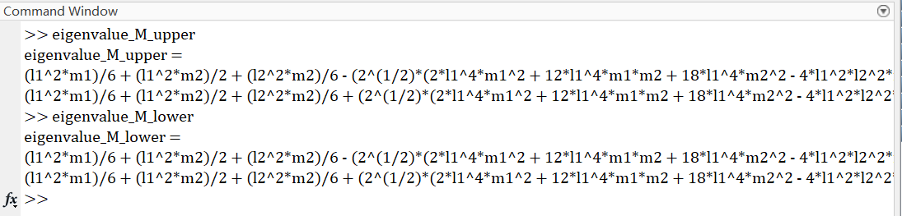

**Fig. W8-2** The results for eigenvalues of M matrix with upper and lower boundary of trigonometric

1. *ODE solver in Simulink*

Though it looks like the ordinary differential equations are solved by directly integration by the integrator block in Simulink facially, actually the ODEs can be solved by different numerical approximation methods (ODE solver) in continuous time depending on our requirement towards the precision of the results. The conclusion is that the motion equation is solved using ODE solvers, and modelling with Simulink is reliable.

For more detailed information, please check via the link below.

<https://www.mathworks.com/help/simulink/slref/integrator.html?s_tid=srchtitle_integrator_2>

1. *Supplement part of exoskeleton used on thigh*

As different subjects have different body features, I have designed a mechanism in which the position of the panel to push the thigh of subjects can be adjusted, and it can be fixed by bolts and nuts as shown in the figure below.

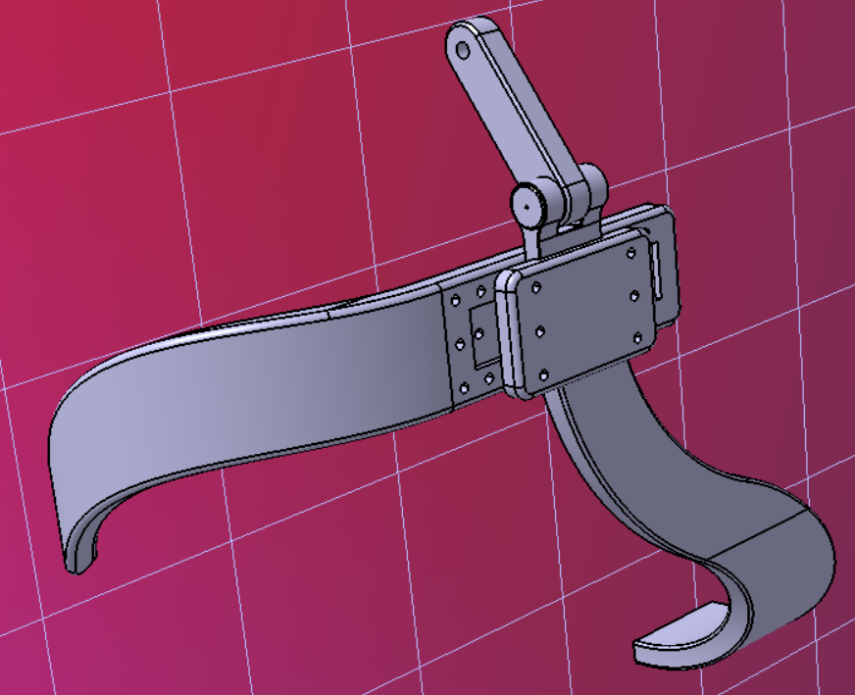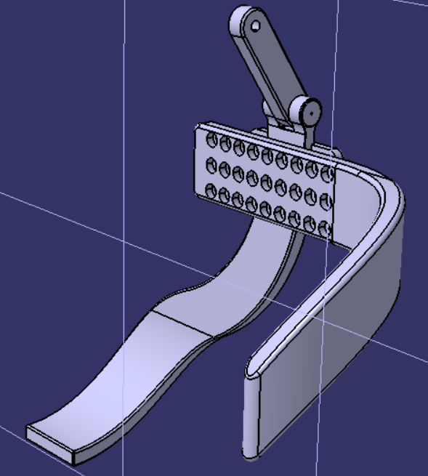

**Fig. W8-3** The schematic of the supplement part working on thigh from different views

## **Plan**

1. Continue with the SRA simulation;
2. Continue to read papers about energy shaping topic (which should be the task for last week, but not finished yet);
3. Take the supplement part I designed into practical use to see if there is anything I could improve or fix.